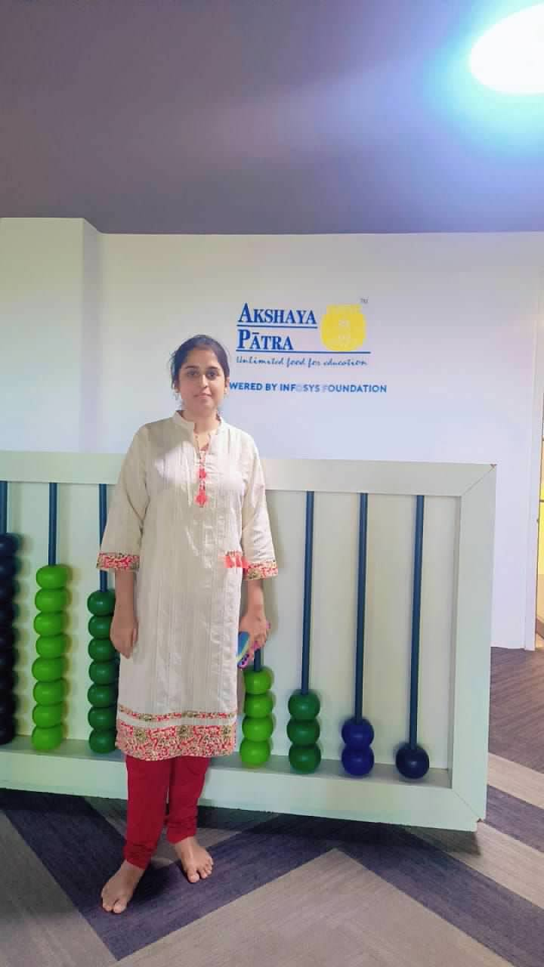

Gnaneshwari Mahimaluru
PGBA25002
PGDM -BA
SOIM - GNITS

Industrial Visit Report
Visit to: The Akshaya Patra Foundation, Kandi, Hyderabad
Date of Visit: 23rd August 2025

1. Introduction

On 23rd August 2025, we had the opportunity to visit The Akshaya Patra Foundation, located in Kandi, Hyderabad. The visit was organized as part of our curriculum to understand the practical implementation of social operations, large-scale logistics, and public-private partnership models.

2. About the Organization
The Akshaya Patra Foundation is a leading non-profit organization committed to eliminating hunger in classrooms. It operates under a Public-Private Partnership (PPP) model in collaboration with the Government of India through the PM POSHAN Abhiyaan (previously known as the Mid-Day Meal Scheme).
Established in 2000, the foundation began with just 1,500 children in Bengaluru and now serves over 2 million children daily across 15 states and 2 union territories.
Vision:
"No child in India shall be deprived of education due to hunger."
Mission:
To feed 3 million children every school day by 2025.

3. Visit Observations
During the visit, we observed the operations at the centralized kitchen. Below are the key areas we explored:
a. Raw Material Handling
All ingredients are tested and stored under hygienic conditions. Quality control is a top priority.
b. Food Preparation
Automated cooking processes ensure that thousands of meals are prepared quickly, hygienically, and uniformly.
c. Packaging and Dispatch
Meals are packed in stainless steel containers and dispatched in GPS-enabled vehicles to schools. The packing process ensures freshness and temperature control.
d. Logistics and Monitoring
The foundation uses logistics planning and tracking systems to deliver food on time across multiple school locations.

4. Key Learnings
- Real-time implementation of operations management in the social sector.
- Understanding logistics and supply chain for daily mass food delivery.
- Observing automation in cooking and hygiene standards.
- Insight into how NGOs collaborate with the government to make lasting impact.

5. Personal Experience
The visit left a lasting impression on me. Witnessing the operations at such scale was inspiring. The dedication of the team and the impact of their work on children's lives emphasized the power of purpose-driven work. It was not just an industrial visit—it was a learning experience that blended empathy with efficiency.

6. Conclusion
The industrial visit to The Akshaya Patra Foundation was highly insightful and motivational. It provided practical exposure to how a non-profit organization can efficiently manage operations and contribute to society. I am grateful for this opportunity and look forward to applying these learnings in future endeavors.

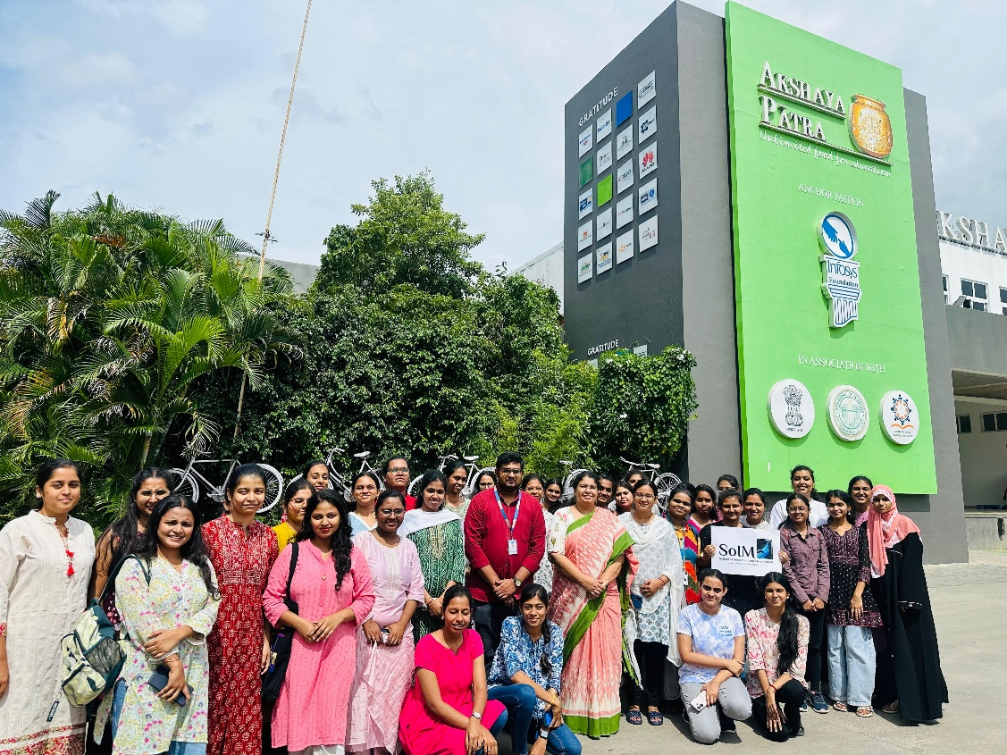

This is the Group Pic that has been taken after visiting the Akshaya Patra

